IceFloe User’s Manual

Pre-draft January 2014

# Ice Model Descriptions

The IceFloe module can optionally calculate loading using one of several models. The models are described briefly here, further details can be found in the noted references. Further guidance on the use of these models can be found in the accompanying theory manual [‎1]. These models include those specified by ISO and IEC standards as well as select alternatives.

Ice loading on offshore structures generally takes one of two forms: crushing of the ice sheet against vertical or near vertical surfaces or flexural failure (bending/snapping) of the ice against coned surfaces. These two configurations are shown in Figure 1 and Figure 2. The different models are listed in Table 1.

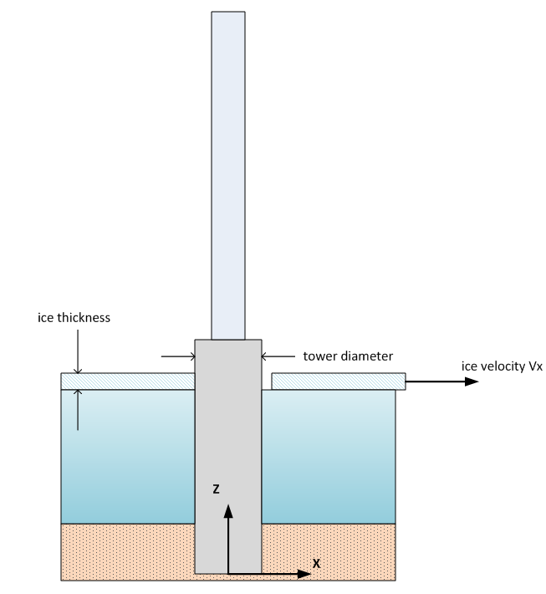

Figure 1 Sketch of ice crushing against a vertical surface

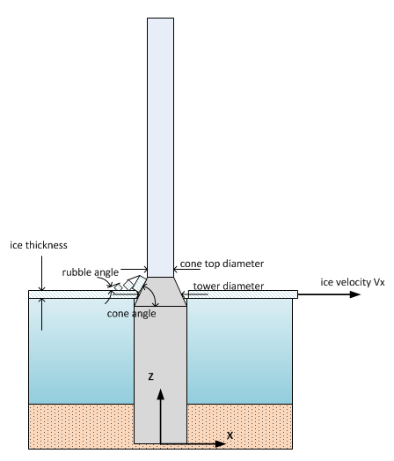

Figure 2 Sketch of ice flexural failure against a coned surface

Table 1 Ice loading models available in IceFloe

|  |  |  |
| --- | --- | --- |
| Ice Load Model | Ice Type Code | Reference |
| Random crushing | 1 | Karna, T., et. al., *A Spectral Model for Forces due to Ice Crushing*, Journal of Offshore Mechanics and Arctic Engineering, May, 2006. |
| Intermittent crushing | 2 | **NEED REF FROM TOM** |
| Lock-in crushing per ISO | 3 | *Petroleum and natural gas industries - Arctic offshore structures*, ISO 19906, first Edition Dec. 15, 2010, Section A.8.2.4.3. |
| Lock-in crushing per IEC | 4 | *Design requirements for offshore wind turbines*, IEC 61400-3, Ed 1, Appendix E. |
| Coupled crushing | 5 | Maattanen, M., *Numerical Model for Ice Induced vibration load lock-in and Synchronization*, Proceedings of the 14th Int. Symp. on Ice, Potsdam, NY USA, 1998, vol 2, pp 923-930. |
| Flexural failure per ISO | 6 | Croasdale, K.R. and Cammaert A.B., *An Improved Method for the Calculation of Ice Loads on Sloping Structures*, Hydrotechnical Construction Vol. 28 No. 3 ,March, 1994. |
| Flexural failure per IEC | 7 | Ralston, T, *Ice Force Design Considerations for Conical Offshore Structures*, POAC conference, 1977  *Design requirements for offshore wind turbines*, IEC 61400-3, Ed 1, Appendix E.  *Petroleum and natural gas industries - Arctic offshore structures*, ISO 19906, first Edition Dec. 15, 2010, Section A.8.2.4.4. |

## Random Crushing

The random crushing model uses the ice sheet velocity as a parameter for a spectral distribution of the ice loading. The distribution is used to create a random time series of loads scaled by the ice strength, thickness and the support structure width (monopile or leg diameter). The load time series is pre-computed in the initialization routine and interpolated in time by the update routine. For multi-leg structures individual independent random time series are generated. An example load time series of random crushing is shown in Figure 3 in the upper left hand corner.

## Intermittent Crushing

The intermittent crushing model is an asymmetrical triangular (sawtooth) waveform with specified period separated by intervals with no load. An example load time series of intermittent crushing is shown in Figure 3 in the upper right hand corner. For multi-leg structures the user must specify a phase angle to be used for the waveform of each leg.

## Lock-In Crushing

The lock-in crushing model applies a periodic waveform at the specified fundamental frequency of the support structure. The ISO code specifies an asymmetrical triangular (sawtooth) waveform and the IEC code specifies a sinusoidal waveform. Example load time series of lock-in crushing are shown in Figure 3 in the middle left and right plots.

## Coupled Crushing

The coupled crushing model is effectively a lock-in type of model wherein the instantaneous magnitude of the load is dependent on the relative velocity between the support structure and the ice sheet.

## Flexural Failure

There are two flexural failure models currently implemented in IceFloe. The model as specified by the ISO code is a series of triangle/sawtooth waveforms with random (although bounded) period and peak heights separated by intervals of no load. The model specified by IEC is a sinusoidal waveform at a frequency substantially below the fundamental structural frequency. The load varies from a non-zero minimum to a maximum specified peak. Examples load time series of flexural failure are shown in Figure 3 in the lower left and right hand corners. For the IEC model with a multi-leg structure the user must specify a phase angle to be used for the waveform of each leg.

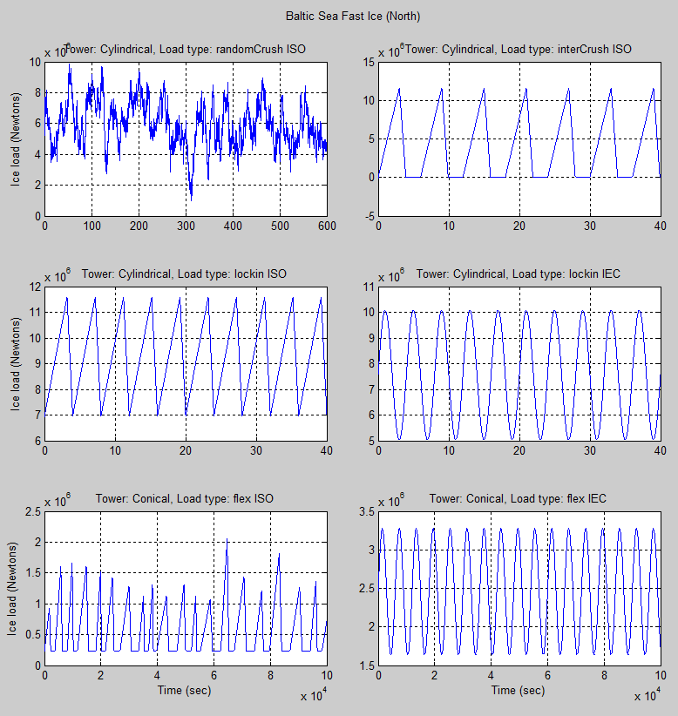

Figure 3 Example ice load time series

## Multiple-Leg Structures

IceFloe can calculate load time series for support structures with one, three, or four legs. When there are multiple legs, time series is calculated individually for each leg. For models with random loading each leg load time series is independent. For models with periodic loading the user must specify a phase angle for each leg. Additionally the user must either specify a sheltering factor for each leg or choose the auto-calculate option for a sheltering factor. This factor accounts for the clearing of ice behind an up-floe leg which reduces the load on the down-floe leg.

For output to the calling program there is an option to provide the ice loads either individually or as a single combined set of forces plus a moment about the vertical axis. See the section on coordinates and load components for more details.

# Coordinate System and Load Components

The coordinate system used by IceFloe is shown in Figure 4. A direction of zero means that the ice is moving and loads are applied in the positive x direction. The sense of a positive rotation of the ice direction is also shown. For a multi-leg structure leg (x,y) coordinates at the waterline are required. An example cross section at the water line is shown in Figure 5. Note the leg coordinates internal to the ice load routine assume that the coordinate origin is at the centroid of the legs.



Figure 4 Definition of ice velocity and direction coordinate system



Figure 5 Arrangement of legs

IceFloe returns force components in the x and y directions in the ground/inertial coordinate system although it is up to the user to insure that the calling program accepts the loads this way. Vertical forces (Fz) are always zero. When loads are requested individually for a multi-leg structure all moments are zero. However for a single point application of equivalent loads for a multi-leg structure modeled as a single beam a vertical moment (Mz) is returned based on a calculation using the individual leg positions and forces.

# Console Program Execution

The console (DOS) executable that will calculate ice loads and save them to a file is found here:

C:\SVN\LoadSimCtl_SurfaceIce\trunk\IceDyn_IntelFortran\IceFloeConsole\Release\iceFloeConsole.exe

This console program takes a single command line argument which is the name of the parameter input file. The program is run from a DOS window by issuing the following command (with the necessary path to the executable included:

Path\iceFloeConsole.exe iceRun.inp

Two files will be created: a log file and a file with the time series of loads, both ASCII:

Path\iceRun.log

Path\iceRun.dat

The data file can be reformatted in Excel or Matlab for example to match the input requirements of the structural analysis program.

# Input File

The input file is an ASCII file that consists of comment lines and input parameter lines. Comment lines are started with an exclamation point (!) in the first column. Input parameter lines consist of a key word followed by a numeric value. See the appendix for an example. A few points about parameter inputs:

* Key words are essentially the variable names and must be spelled correctly but are not case sensitive.
* The order of the input parameters is not important
* Not all input parameters are required for every ice loading type, however if a required parameter is missing a warning message will be issued to the screen and to the log file.

A list of all possible input parameters is found in Table 2 along with units, suggested typical values where appropriate, input checking limits, descriptive notes, and which ice loading type they are required by. Additionally, Table 3 through Table 5 list the input parameters specifically required for each ice loading type.

Table 2 IceFloe Input Parameters

|  |  |  |  |  |  |
| --- | --- | --- | --- | --- | --- |
| **Parameter Name** | **Typical Value\*** | **Limits** | **Units** | **Notes** | **Used by ice load type** |
| coeffBreakLength | 4 | 3 to 10 | - | Multiple of ice thickness for length of ice slab between breaks | ISO flexural failure model |
| coeffLoadMin | 0.1 | 0 to 1 | - | Coefficient relating minimum load to peak load | ISO flexural failure model |
| coeffLoadPeaks | 0.56 | 0.1 to 1.0 | - | Coefficient relating mean load to peak load | ISO flexural failure model |
| coeffPSD_b | 1.34 | 0.1 to 3 | - | Parameter for PSD of random crushing load | Random crushing |
| coeffPSD_ks | 3.24 | 1 to 5 | - | Parameter for PSD of random crushing load | Random crushing |
| contactFactor_k2 | - | 0.1 to 2 | - | Parameter for static ice crushing load | IEC crushing models |
| crushLoadCOV | - | 0.1 to 1 | - | Coefficient of variation of load | Random crushing |
| duration | - | >0 | sec | Length of the load time series | All |
| fallTime | - | 0.1 to 0.9 | - | Fall time for sawtooth waveform – as a fraction of the period | ISO flexural and ISO and intermittent crushing models. |
| flexStrength | - | 0 to 1E9 | Pascals | Ice breaking strength in flexural failure | ISO and IEC flexural failure models |
| freqParamK | 5 | 4 to 7 | - | Parameter for determination of the frequency of flexural loading – multiple of ice thickness | IEC flexural failure model |
| freqStep | - | 0.001 to 0.1 | Hz | Frequency resolution for PSD of random loads. | Random crushing |
| frictionAngle | - | 0 to 70 | degrees | Angle at which the ice slides **CHECK** | ISO flexural failure model |
| ice2iceFriction | 0.05 | 0 to 1 | - | Friction between ice blocks | ISO flexural failure model |
| ice2twrFriction | 0.1 | 0 to 0.3 | - | Friction coefficient between ice and tower surface | ISO and IEC flexural failure models |
| iceDensity | 917 | >0 | kg/m3 | Density of the ice | ISO and IEC flexural failure models |
| iceDirection | 0 | 0 to 360 | degrees | Direction of ice sheet movement – see coordinate description | All |
| iceModulus | - | >0 | Pascals | Modulus of elasticity of the ice | ISO flexural failure model |
| iceThickness | - | 0.001 to 100.0 | meters | Thickness of the ice sheet | All |
| iceType | 1 to 7 | 1 to 7 | - | See explanation in section TBD | All |
| iceVelocity |  | 0.001 to 10.0 | m/s | Speed of the ice sheet | All |
| includeHb | 1 | 0 or 1 | - | Switch to turn breaking load term on/off | ISO and IEC flexural failure models |
| includeHl | 1 | 0 or 1 | - | Switch to turn ice lifting load term on/off | ISO flexural failure model |
| includeHp | 1 | 0 or 1 | - | Switch to turn ice pile load term on/off | ISO flexural failure model |
| includeHr | 1 | 0 or 1 | - | Switch to turn rubble ride up load term on/off | ISO and IEC flexural failure models |
| includeHt | 1 | 0 or 1 | - | Switch to turn ice block rotation load term on/off | ISO flexural failure model |
| includeLc | 1 | 0 or 1 | - | Switch to turn crack length modification term on/off | ISO flexural failure model |
| interPeriod | - | > 1.0 | sec | Period of the sawtooth waveform | Intermittent crushing |
| legAutoFactor | 1 | 0 or 1 | - | Automatically calculate the shelter factors for a multi-leg structure | All |
| legX# | 0 | None | meters | X location of leg number # - need an input for each of numLegs, (0,0) is centroid | All |
| legY# | 0 | None | meters | Y location of leg number # - need an input for each of numLegs (0,0) is centroid | All |
| loadPhase# | 0 | 0 to 360 | degrees | Phase for sinusoidal load of leg number # - need an input for each of numLegs | IEC crushing, IEC Flex, ISO intermittent and lock-in crushing |
| minLoadFraction | - | 0 to 1 | - | The minimum load expressed as a fraction of the maximum load | ISO lock-in crushing |
| minStrength | - | 0 to 1E9 | Pascals | Minimum ice strength in stress rate to strength calculation | Coupled crushing |
| multiLegFactor_kn | 0.9 | 0.0 to 1.0 | - | Reduction in peak load to account for non-simultaneous loading of multiple legs | Lock-in crushing (IEC and ISO) |
| numLegs | 1 | 1,3, or 4 | - | Number of legs in support structure | All |
| peakLoadCOV | 0.2 | 0.1 to 0.5 | - | Coefficient of variation of peak load | ISO flexural failure model |
| periodCOV | - | 0.1 to 0.9 | - | Coefficient of variation of sawtooth waveform period | ISO flexural failure model |
| poissonRatio | 0.3 | 0 to 0.5 | - | Poisson’s ratio | ISO flexural failure model |
| randomSeed | - | >0 | - | Initial seed for some models | ISO flexural failure and random crushing |
| refIceStrength | - | 0.5E6 to 50 E6 | Pascals | Parameter for static ice crushing load | ISO, random, and IEC crushing models |
| refIceThick | 1 | 1 | meters | Parameter for static ice crushing load | ISO and random crushing models |
| rideUpThickness | - | >0 | meters | Ice pile up term | IEC flexural failure model |
| riseTime | - | 0.1 to 0.9 | - | Rise time for sawtooth waveform – as a fraction of the period | ISO flexural and ISO and intermittent crushing models. |
| rubbleAngle | - | 0 to 70 | degrees | Angle the rubble pile makes with the horizontal | ISO flexural failure model |
| rubbleCohesion | 0 | >0 | Pascals | Sort of like a breaking strength of the rubble pile | ISO flexural failure model |
| rubbleHeight | - | >0 | meters | Height of rubble pile | ISO flexural failure model |
| rubblePorosity | 0.3 | 0 to 1 | - | Sort of like density of the rubble pile | ISO flexural failure model |
| shapeFactor_k1 | - | 0.1 to 1 | - | Parameter for static ice crushing load | IEC crushing models |
| shelterFactor_ks | 1 | 0.0 to 1.0 | - | Fraction of load to be applied to legs sheltered by “up floe” legs | All |
| singleLoad | 0 | 0 or 1 | - | Whether to return loads from individual legs or combined as a set of forces and a torsion | All |
| staticExponent | -0.16 | -0.16 | - | Exponent parameter for static ice crushing load | ISO and random crushing models |
| stdLoadMult | 4 | 1 to 6 | - | Multiplier for range of load in multiples of the stdev | Random crushing |
| tauMax | - | 0.1 to 1 | - | Maximum fraction of the sawtooth waveform period for active load change | ISO flexural failure model |
| tauMin | - | 0.1 to 0.8 | - | Minimum fraction of the sawtooth waveform period for active load change | ISO flexural failure model |
| timeStep | 0.1 | >0 | sec | Time step resolution of precalculated time series of loads | All |
| towerConeAngle | - | 20 to 70 | degrees | Angle of coned tower surface measured from horizontal | IEC and ISO Flexural failure |
| towerDiameter | - | 0.1 to 100 | meters | Diameter of monopole or of an individual leg | All |
| towerFrequency | - | 0.1 to 10 | Hz | Fundamental tower frequency | IEC crushing, ISO lock-in crushing |
| twrConeTopDiam | - | >0 | meters | Diameter of support structure at the top of the coned section | IEC Flexural failure |
| waterDensity | 1000 | >0 | kg/m3 | Density of the water | ISO flexural failure model |

* These are suggested not assigned as default

Table 3 Input Parameters for Crushing Failure Models

|  |  |  |  |  |
| --- | --- | --- | --- | --- |
| **Random Crushing** | **Intermittent Crushing** | **ISO Lock-In Crushing** | **IEC Lock-In Crushing** | **Coupled Crushing** |
| randomSeed | randomSeed | randomSeed | randomSeed | randomSeed |
| timeStep | timeStep | timeStep | timeStep | timeStep |
| duration | duration | duration | duration | duration |
| iceThickness | iceThickness | iceThickness | iceThickness | iceThickness |
| iceVelocity | iceVelocity | iceVelocity | iceVelocity | iceVelocity |
| iceDirection | iceDirection | iceDirection | iceDirection | iceDirection |
| refIceStrength | refIceStrength | refIceStrength | refIceStrength | refIceStrength |
|  |  |  |  | minStrength |
| numLegs | numLegs | numLegs | numLegs | numLegs |
| towerDiameter | towerDiameter | towerDiameter | towerDiameter | towerDiameter |
|  |  | towerFrequency | towerFrequency |  |
| iceType | iceType | iceType | iceType | iceType |
| refIceThick | refIceThick | refIceThick | shapeFactor_k1 |  |
| staticExponent | staticExponent | staticExponent | contactFactor_k2 |  |
| coeffPSD_b | interPeriod | riseTime |  |  |
| coeffPSD_ks | riseTime | minLoadFraction |  |  |
| crushLoadCOV | fallTime |  |  |  |
| stdLoadMult |  |  |  |  |
| freqStep |  |  |  |  |
|  |  |  |  |  |

Table 4 Input Parameters for Flexural Failure Models

|  |  |
| --- | --- |
| **ISO Flexural Failure** | **IEC Flexural Failure** |
| randomSeed | randomSeed |
| timeStep | timeStep |
| duration | duration |
| iceThickness | iceThickness |
| iceVelocity | iceVelocity |
| iceDirection | iceDirection |
| flexStrength | flexStrength |
| iceModulus |  |
| iceDensity | iceDensity |
| waterDensity |  |
| numLegs | numLegs |
| towerDiameter | towerDiameter |
| towerConeAngle | towerConeAngle |
| rubbleHeight | twrConeTopDiam |
| ice2twrFriction | ice2twrFriction |
| iceType | iceType |
| rubblePorosity | rideUpThickness |
| rubbleCohesion | freqParamK |
| rubbleAngle |  |
| frictionAngle |  |
| ice2iceFriction |  |
| poissonRatio |  |
| peakLoadCOV |  |
| coeffLoadPeaks |  |
| coeffLoadMin |  |
| periodCOV |  |
| tauMin |  |
| tauMax |  |
| riseTime |  |
| coeffBreakLength |  |
| includeHb | includeHb |
| includeHr | includeHr |
| includeHp |  |
| includeHl |  |
| includeHt |  |
| includeLc |  |

For multi-leg structures the parameters in Table 5 apply for all ice load types except as noted.

Table 5 Input Parameters Required for Multi-Leg Models

|  |
| --- |
| legXN (one value for each leg, N=1,2,…) |
| legYN (one value for each leg) |
| shelterFactor_ksN  (one value for each leg) |
| loadPhaseN |
| singleLoad |
| legAutoFactor |
| multiLegFactor_kn (Lock-In only) |

# Code Structure

The following is a description of the code structure for use when attempting to understand and/or modify the code. IceFloe is written in Fortran compliant with the 2003 standard. The IceFloe code is set up as a number of Fortran modules with a building block approach since many of the ice load models use common variables and calculations but not all models use all of these. The modules call initialization and update functions in a cascading fashion as shown in Figure 6 and Figure 7. Note that the coupled crushing output routine does not use the standard routine since it uses state information from the structure at each time step.

With the exception of the coupled crushing model the load time series is pre-calculated in the initialization routine and interpolated with respect to time at each call to the update routine. Note that the coupled crushing output routine does not use the base routine since it uses state information from the structure at each time step.

Intel(R) Visual Fortran Compiler XE 14.0.0.103 [IA-32] with Visual Studio 2008 standard edition were used for compling/linking.



Figure 6 Initialization hierarchy



Figure 7 Update hierarchy

## API

For adaptation to calling programs not currently supported, use any of the following as a template:

* IceFloe.f90 (FAST testing)
* IceFloe.f90 for the console
* HAWC2_DLL.f90

These samples have examples of initialization and update routines.

# References

1. THEORY MANUAL